Jose Pepe Gancedo
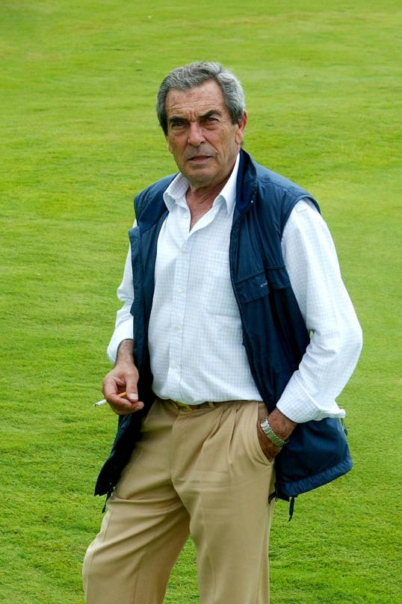
The famous Spanish course designer Pepe Gancedo
also known as the”Picasso of Golf”.
(Credit: Chaparral Golf)

A standout Spanish golfer and a distinguished golf architect who earned the moniker the “Picasso of Golf”. A remark coming from a famous English journalist by the name of Peter Dobereiner, who writes for The Observer.

Considered a genius and a creative designer, Pepe Cancedo is like a painter who makes use of the natural shape and terrain of the landscape he designs. His method consists of feeling the entire course to draw out its personality. From the trees on the field - coconut trees in Cuba, olive trees in Spain, willows in South Africa, and so on… to the “rough” or vegetation outside the fairways. He finds the beauty in everything that surrounds the field and blends them together to evoke a depth of feeling. The result is a course with its own persona.

His first course which launched his professional career as an architect was the Torrequebrada. Other famous courses he designed were the Foressos Golf, El Chaparral, Golf del Sur, Costa Adeje, and Monte Mayor in Spain; Parque da Floresta in Portugal and the Cocotal Golf & Country Club together with the White Sands Golf Course in the Dominican Republic. He designed a total of 18 courses in his career.

